Ben Douglas

02-22-2025

7-2 Project Two Submission- Assignment

README

This is all my screenshots of my animal_shelter.py:

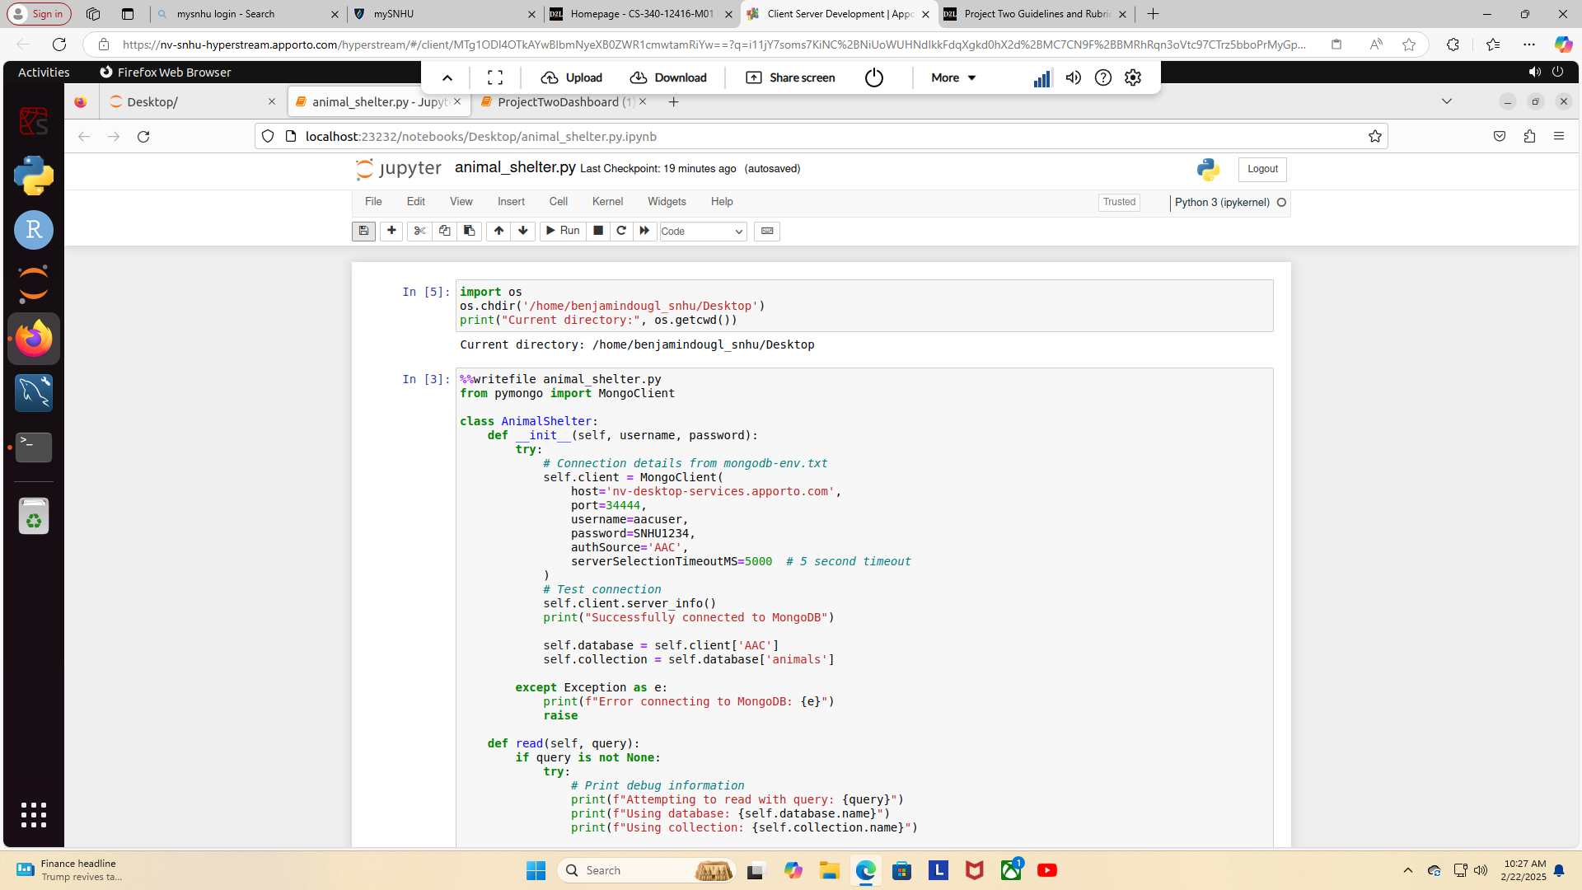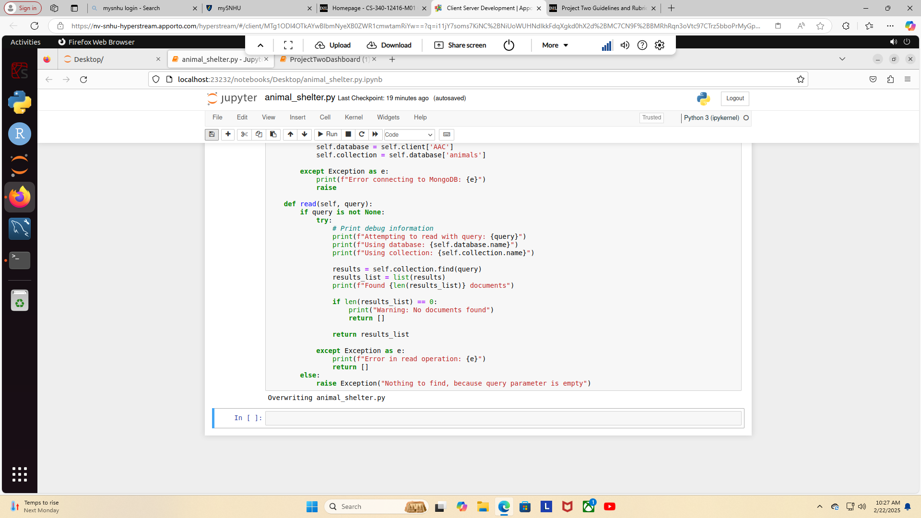This is all my screenshots of ProjectTwoDashboard(1):

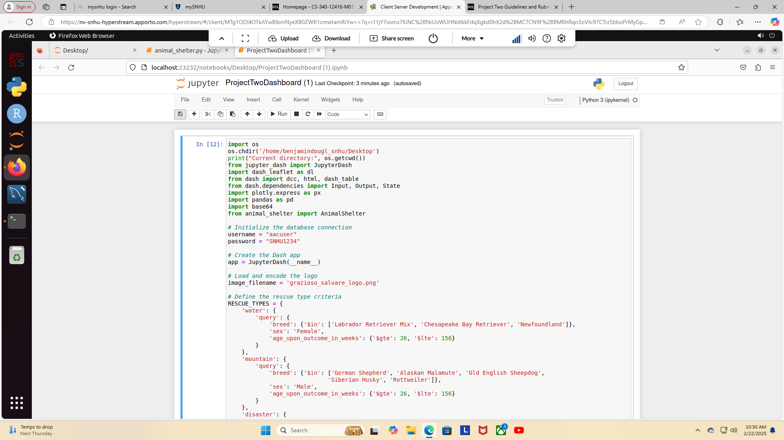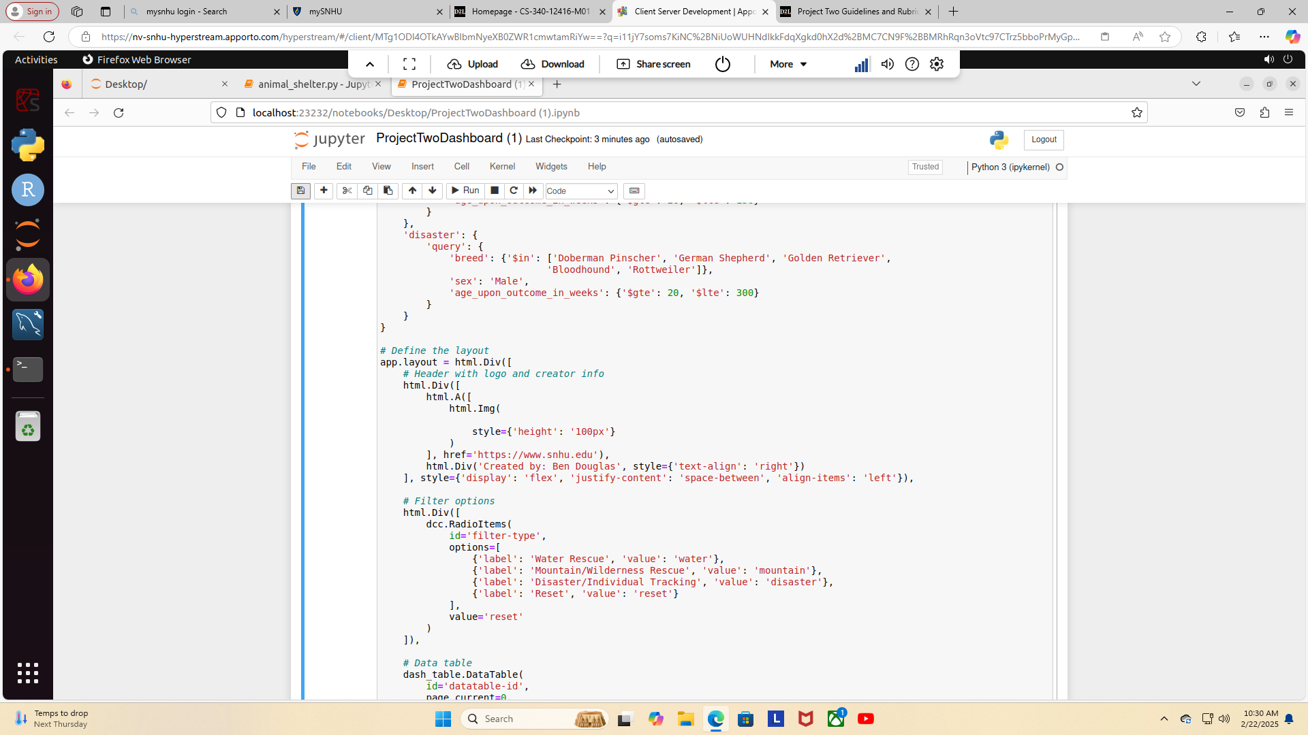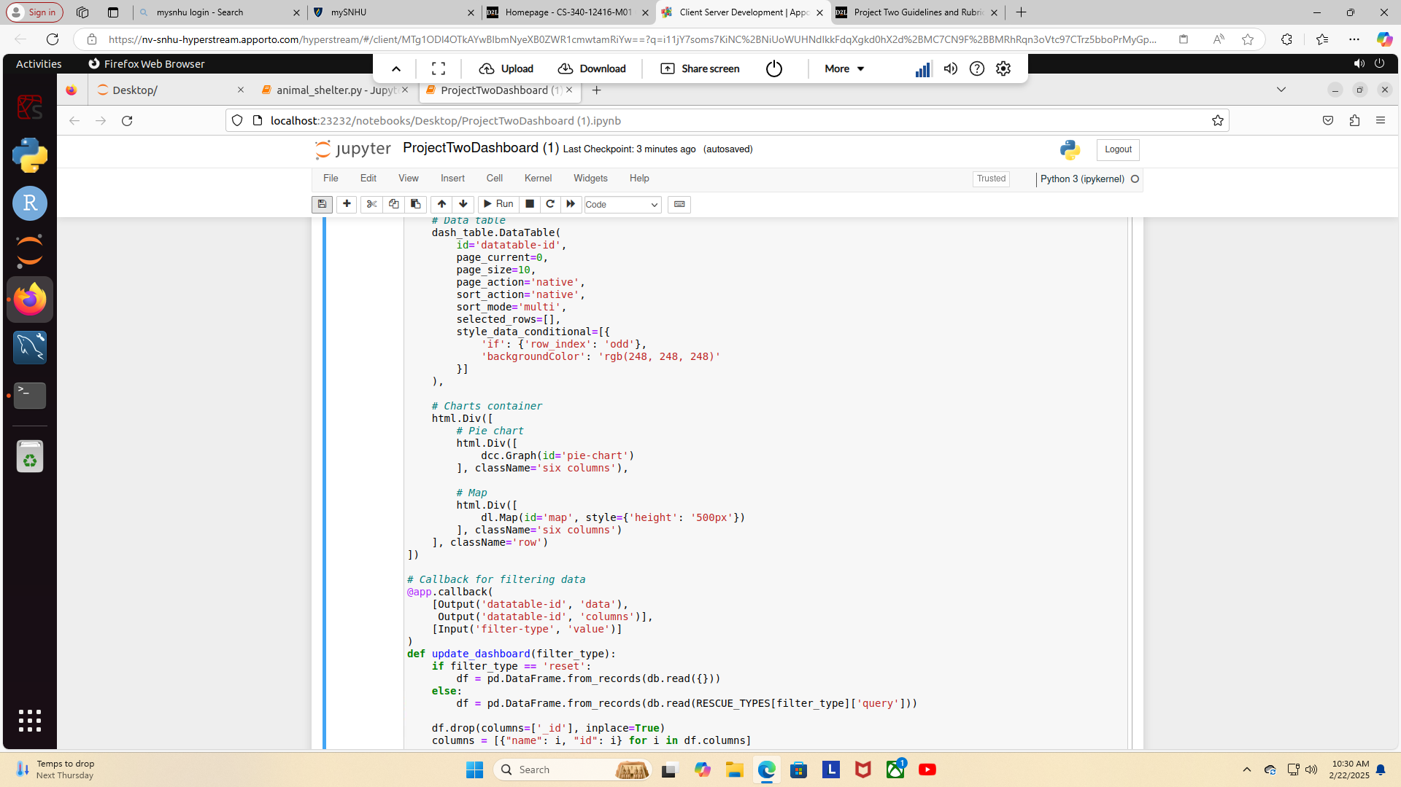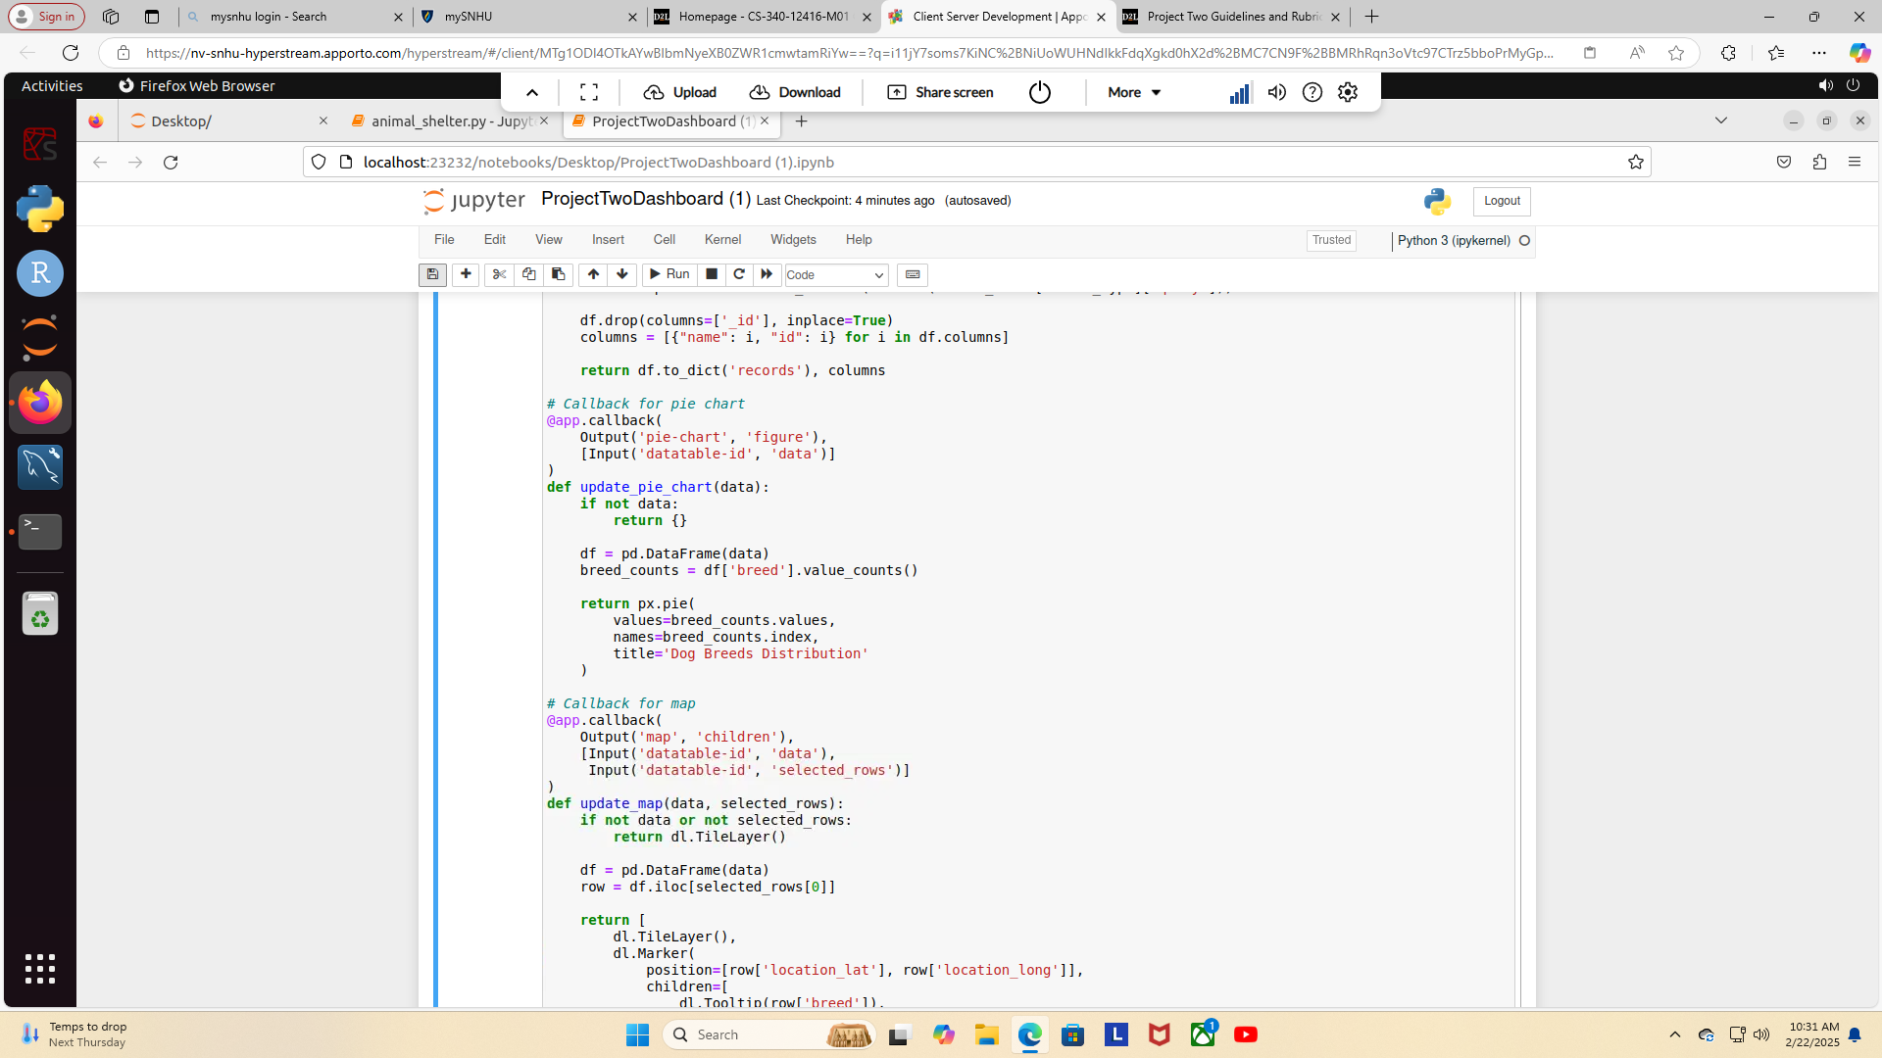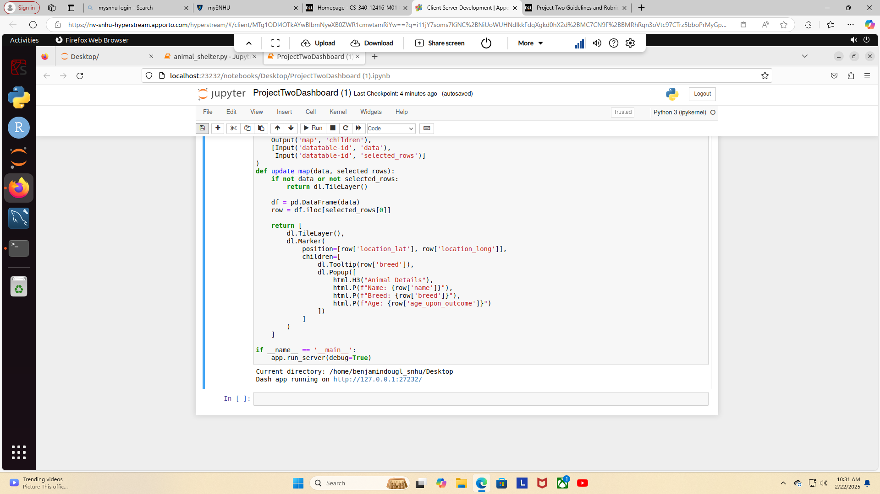This is all my screenshots of my Dash:

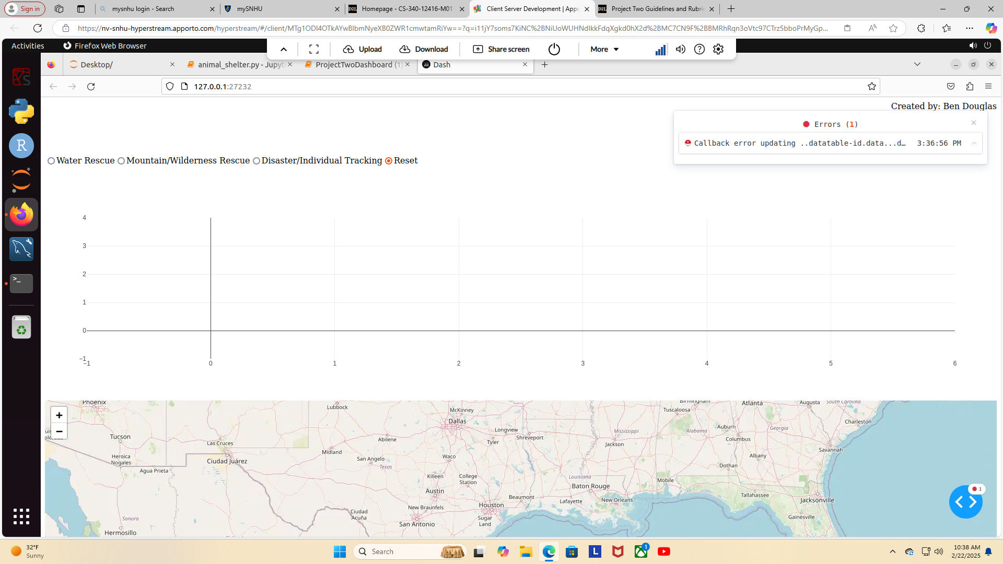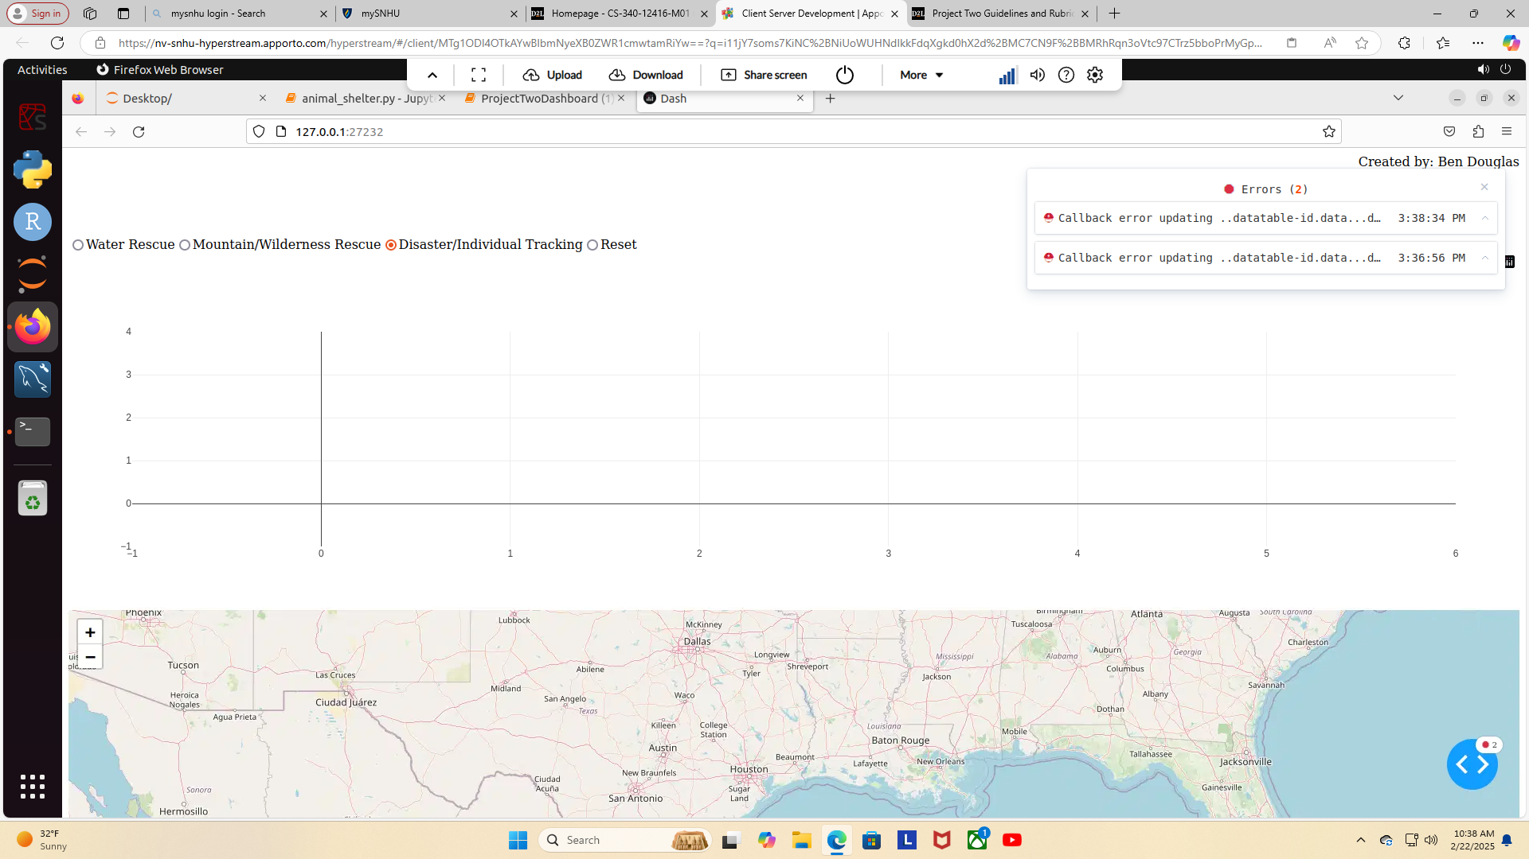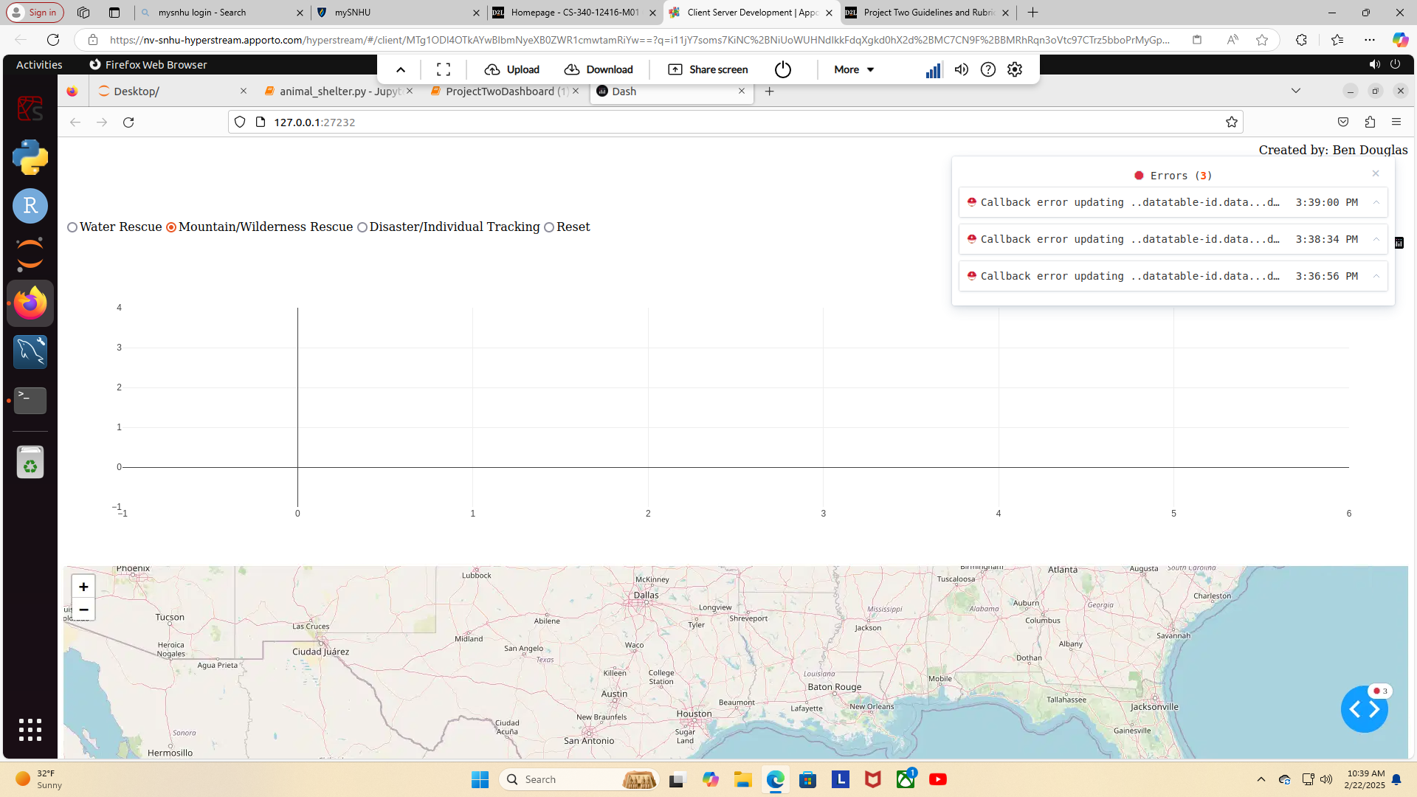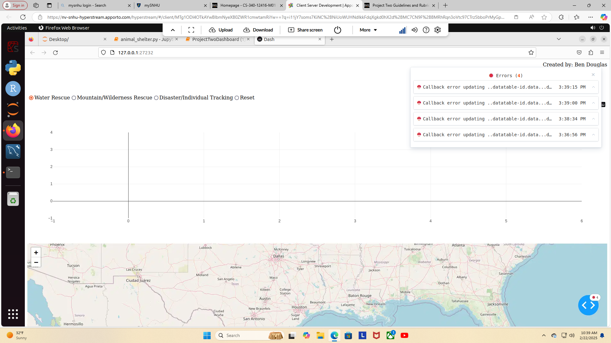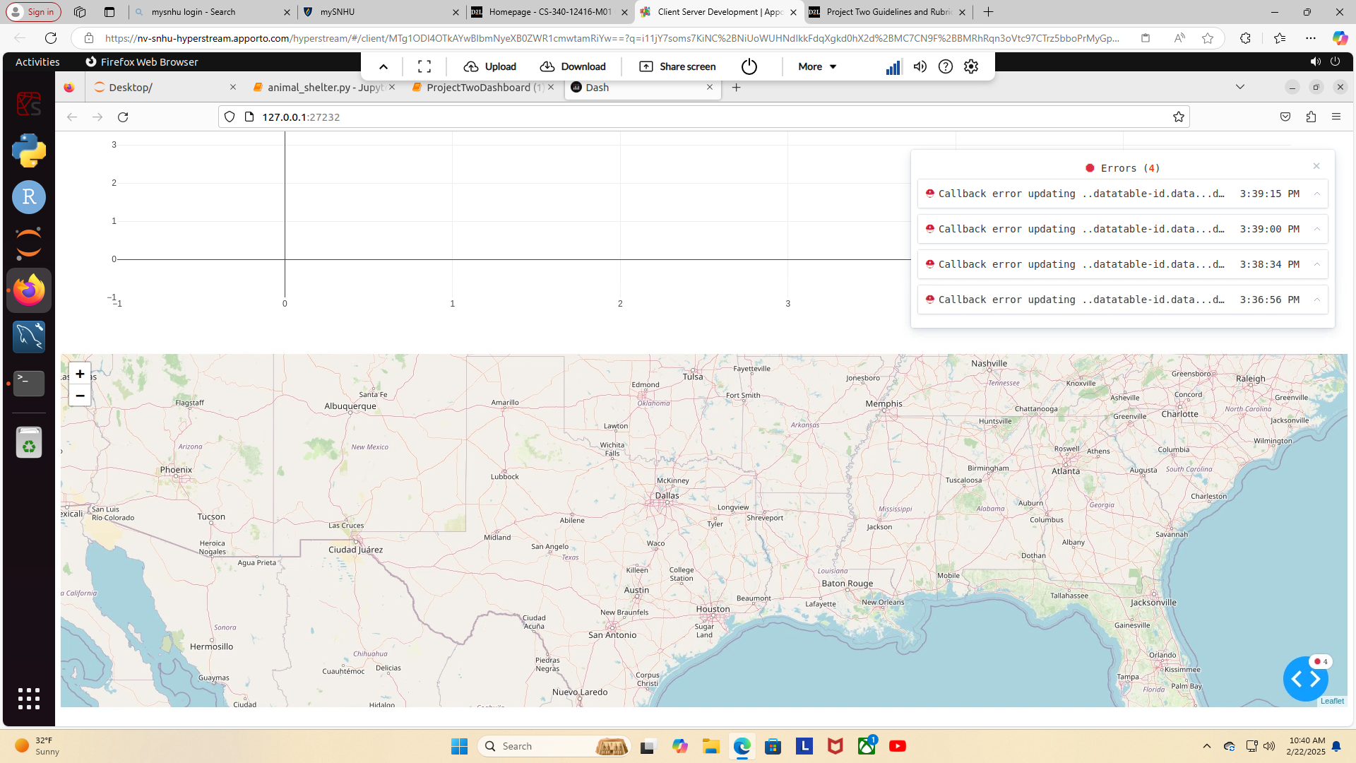 MongoDB was used as the model component of the development, because it had all the information of the animals, and map locations. The specific qualities or capabilities that MongoDB has for interfacing with Python are flexible document-oriented structure for seamless integration, and efficient data manipulation.

The Dash framework that provides the view and controller structure for the web application allows the user to select reset, water rescue, mountain/wilderness rescue, or disaster/individual tracking. It also shows a map of the selections.

Here are links to the resources and software applications that I used: <https://learn.snhu.edu/content/enforced/1831814-CS-340-12416.202511-1/course_documents/ProjectTwoDashboard.ipynb?_&d2lSessionVal=ScQoRYLN9OTGv4T9RbCyYwie6&ou=1332057&ou=1831814>

<https://learn.snhu.edu/content/enforced/1831814-CS-340-12416.202511-1/course_documents/CS%20340%20Dashboard%20Specifications%20Document.pdf?_&d2lSessionVal=ScQoRYLN9OTGv4T9RbCyYwie6&ou=1332057&ou=1831814>

The steps that I took to complete the project are I first read the instructions, then I read the support materials, then I edited my animal_shelter.py, then I edited my ProjectTwoDashboard.ipynb(1), and finally I made sure the Dash was running.

The challenges that I encountered are errors in my animal_shelter.py, and errors in my ProjectTwoDashboard.ipynb(1). These challenges were overcome by first looking over my code to figure out the lines of errors, then I researched them, and finally I fixed the errors to get the app up and running.